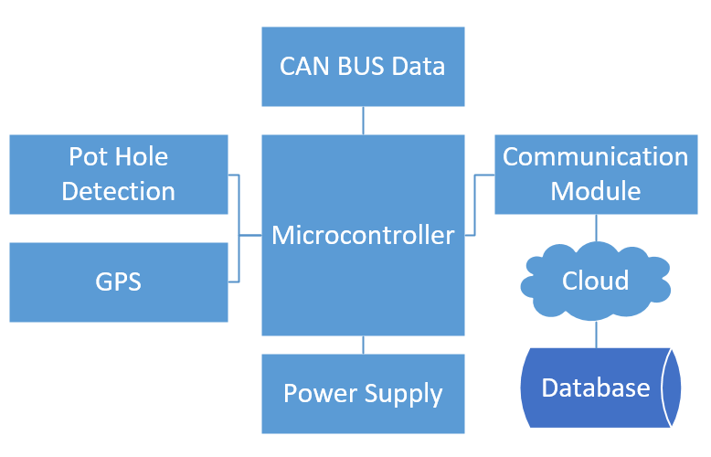

| **Subsystem** | **Functional requirements** | **Design alternatives** |
| --- | --- | --- |
| Power Supply | 1. 12v supply from Battery 2. Must power (step-down)    1. Micro    2. IMU    3. GPS 3. Protection circuit | * Car battery |
| Microcontroller | * Support Can bus * Support I2C * UART | * Raspberry Pico * Raspberry Zero * STM32F103RB |
| Vehicle Telematics | * Receive real-time data from vehicle * Traction control | * OBD2 cable   + Can bus   + ISO 9141   + SAE J1850 |
| Communication to Server/Database | * Communication to cloud via 4G | * Lora * 4g/LTE |
| GPS | * Good accuracy * Ease of use | * GPS * Assisted GPS |
| Pot-hole Detection | * Acquire acceleration in Z-axis | * IMU 6050 |

Unique identifier for a car

* GUID